**International Journal of Renewable Energy Research (IJRER)**

**Editorial Process**

**Step 1:** Go to homepage and enter your username and password. (http://www.ijrer.org/)



**Step 2:** Click on the text titled *Unassigned* in the screen.



**Step 3:** Click on one of the submissions in the screen.

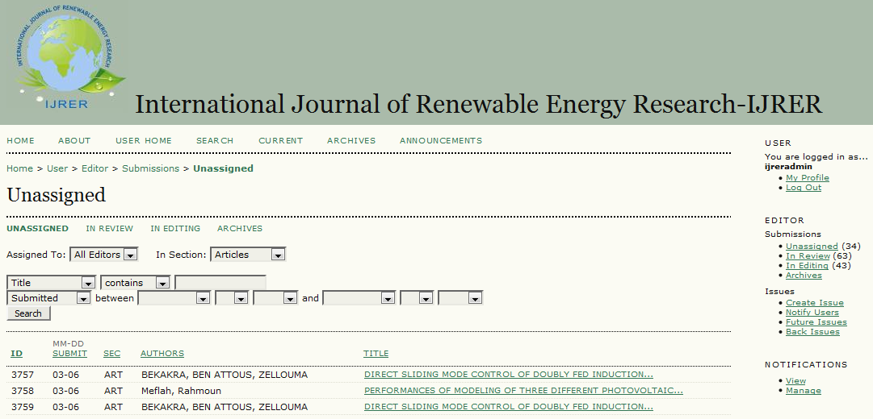

**Step 4:** Click on the text titled *ADD EDITOR* in the screen.

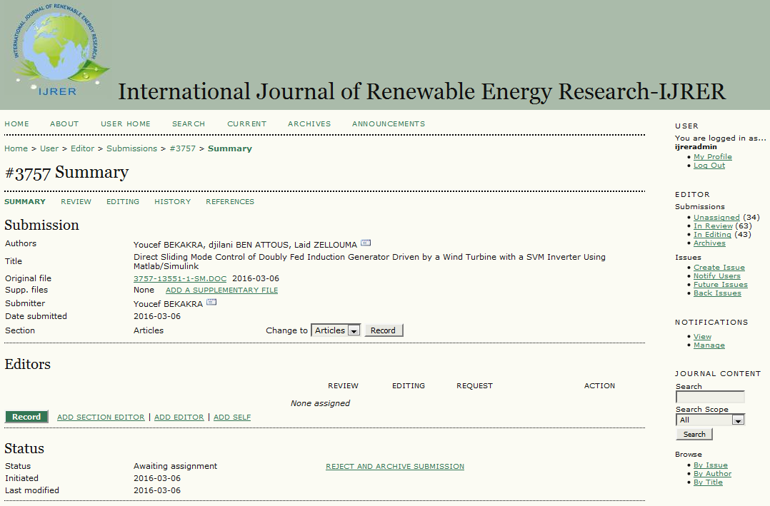

**Step 5:** Assign one or more editors to the related submission.

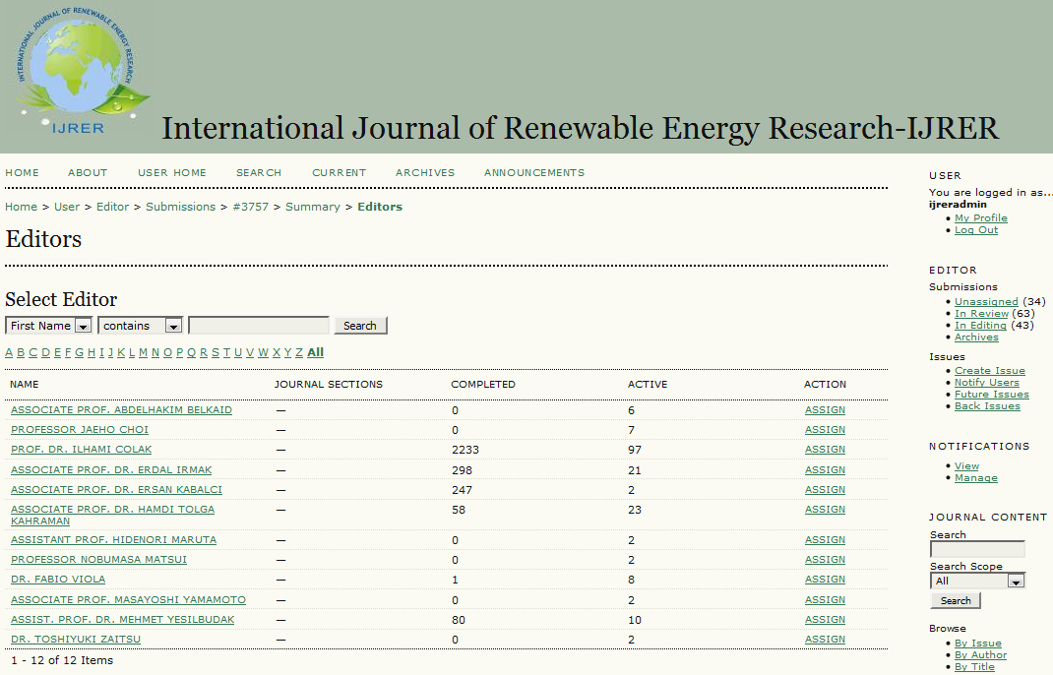

**Step 6:** Click on the text titled *In Review* in the screen.

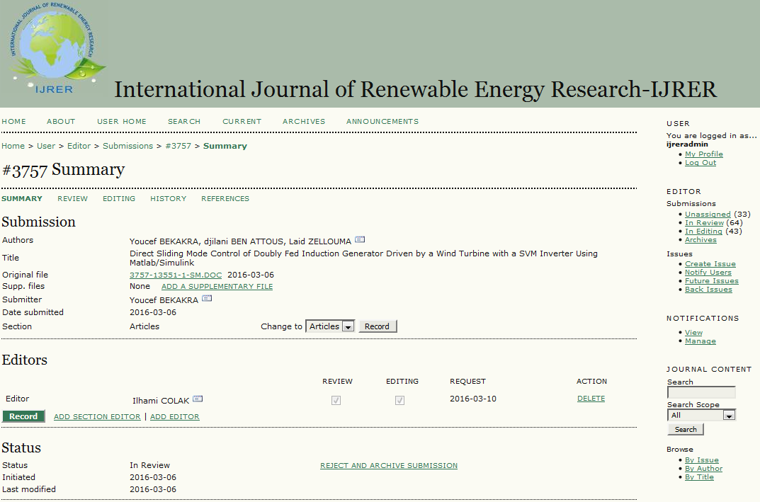

**Step 7:** Click on the title of the related submission that assigned to you for the editorial process in the screen.

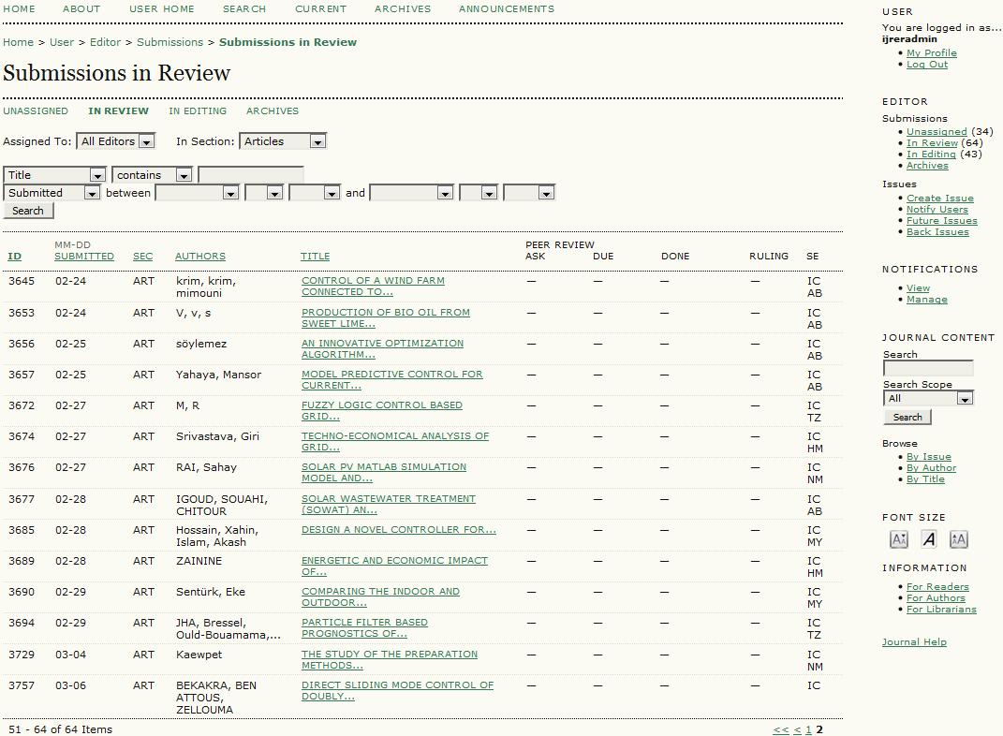

**Step 8:** Click on the text titled *SELECT REVIEWER* in the screen.

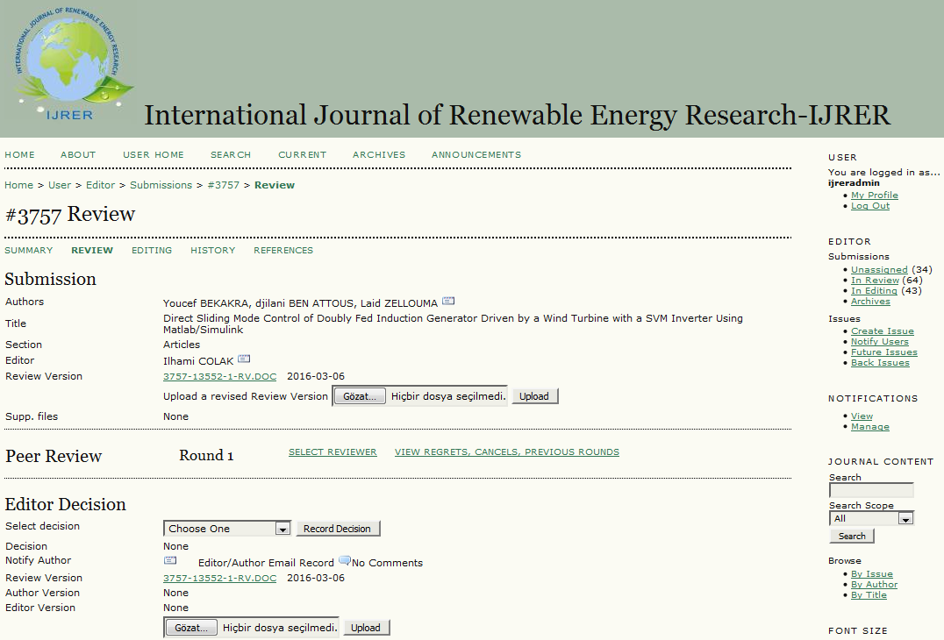

**Step 9:** Write the reviewing interest and assign 3 reviewers at least in the screen. If you want to add new reviewers, click the text titled *CREATE NEW REVIEWER* in the screen.

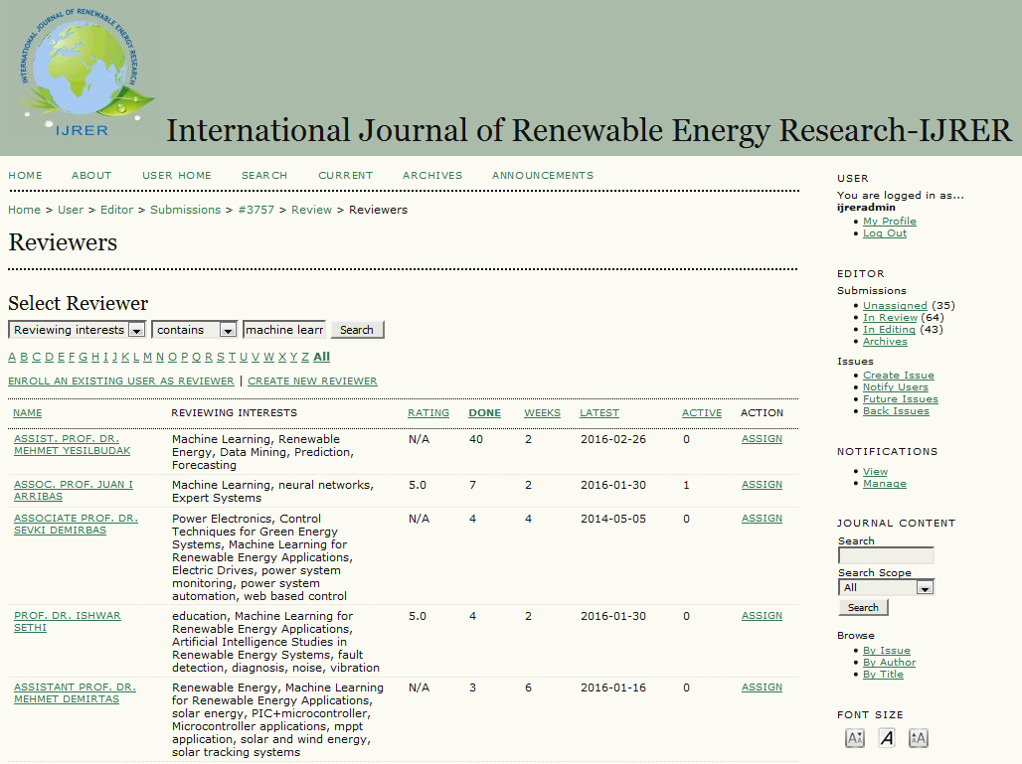

**Step 10:** Click on the text titled *SELECT REVIEW FORM* in the screen.



**Step 11:** Click on the *REQUEST* button in order to send a review invitation in the screen. When a reviewer uploads its evaluations, click the *ACKNOWLEDGE* button in the screen.

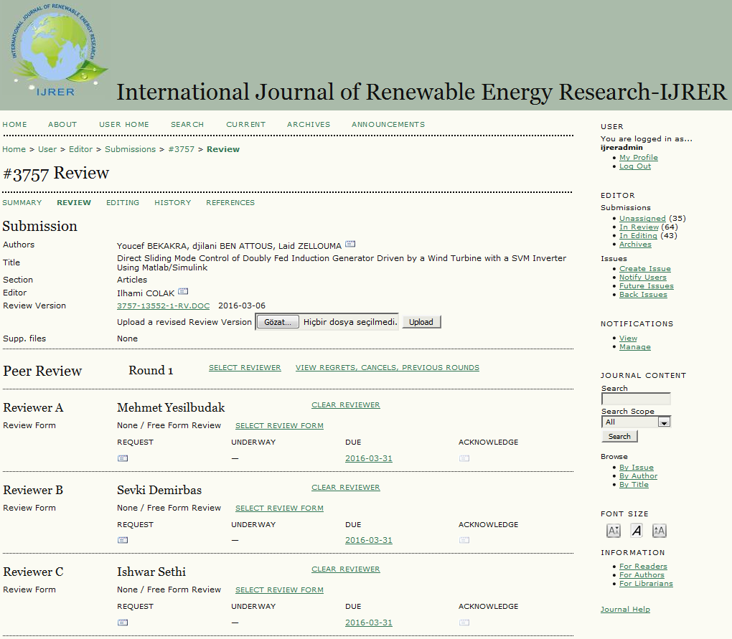

**Step 12:** Select the *Editor Decision* after receiving all of reviewers’ responses in the screen.



**Step 13:** Click on the *Notify Author* button in order to send editor decision in the screen.



**Step 14:** In case the editor decision equals to *Decline Submission*, the related submission will be archived automatically. If the editor decision equals to *Resubmit for Review*, the reviewing process will be restarted after receiving the revised paper. In case the editor decision equals to *Revisions Required*, you should select your final decision about the submission after receiving the revised paper. If the editor decision equals to *Accept Submission*, you should send the accepted submission to the *Editing Stage*.



**Step 15:** Click on the text titled *ASSIGN COPYEDITOR* in order to start copyediting process and click the *REQUEST* button in order to send the copyediting request in the screen.

